|  |
| --- |
| Development Impact Evaluation |
| Burkina Faso Baseline Report |
| [Document subtitle] |

|  |
| --- |
| May 2018 |

# Introduction

The baseline report will have the following parts:

* Introduction
* Sampling and data collection procedures
* Descriptive analysis of the Tree planting baseline data
  + This part will be a simple description of the number of tree planted per forests and blocs, supported by some nice maps that we have produced before
* Descriptive analysis of the Household baseline data (module by module)
  + This is what you are already doing.
* Discussion and next steps
* Conclusion

# Baseline Household Survey

# Data Collection

The Burkina Faso baseline household survey consists of modules on (i) identification of survey participants, (ii) socio-demographic characteristics, (iii) assets, (iv) agricultural production and (v) patterns of food expenditure with a recall period of 7 days.

The data collection activities took place in the field between August 15, 2017 and October 21, 2017.

# Identification of survey participants

The total number of interviewed participants was 630 and the survey implementation was carried out at the region, foret and bloc levels. The chosen four regions in Burkina Faso were Boucle du Mouhoun, Centre Ouest, Est, and Sud Ouest. Next, 10 forets were then selected within the four regions and finally, the households were randomly selected from 33 blocs from within the forets. The aim was to sample an equal number of households into the treatment and control groups from each bloc.

Figure 1, figure 2 and table 1 below provide solid evidence of this balance. Figure 1 indicates a uniform representation of control and treatment households across the regions with Boucle du Mouhoun accounting for the biggest proportion of participants. Bontioli and Tapoaboopo are, according to figure 2, the forets with the highest proportions of control and treatment households. The number of control and treatment groups in each bloc is relatively even (table 1).

Fig. 1. Survey participants by region and treatment status

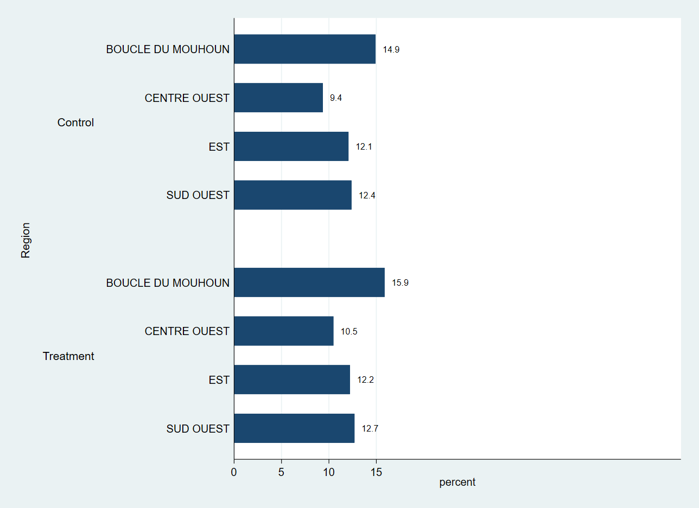

Fig. 2. Survey participants by foret and treatment status

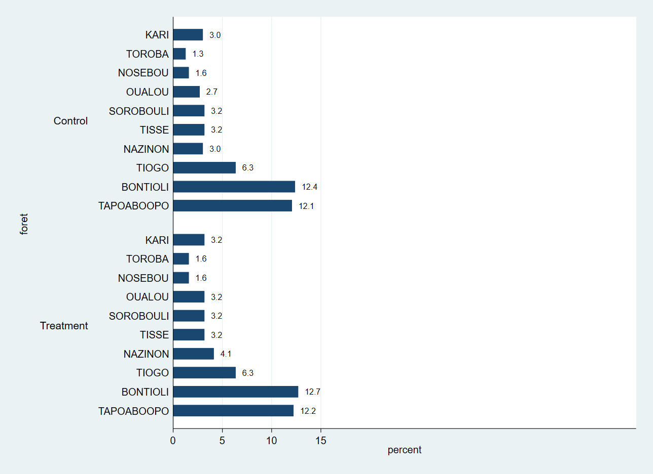

|  |  |  |  |  |  |  |
| --- | --- | --- | --- | --- | --- | --- |
| Table 1. Sample size by forest and bloc | |  |  |  |  |  |
| **Numero du bloc** | **Control** | **Treatment** | **Total** | **Control** | **Treatment** | **Total** |
| BANOUBA | 7 | 10 | 17 | 41.2% | 58.8% | 100.0% |
| BARO | 10 | 10 | 20 | 50.0% | 50.0% | 100.0% |
| BISSANDEROU | 10 | 10 | 20 | 50.0% | 50.0% | 100.0% |
| BONTIOLI | 10 | 10 | 20 | 50.0% | 50.0% | 100.0% |
| BOROMISSI | 10 | 10 | 20 | 50.0% | 50.0% | 100.0% |
| BOUROUM | 10 | 10 | 20 | 50.0% | 50.0% | 100.0% |
| DANKOTNAZOU | 8 | 10 | 18 | 44.4% | 55.6% | 100.0% |
| DASSA | 10 | 10 | 20 | 50.0% | 50.0% | 100.0% |
| DIDIE | 10 | 10 | 20 | 50.0% | 50.0% | 100.0% |
| ETOUAYOU | 10 | 10 | 20 | 50.0% | 50.0% | 100.0% |
| GALO | 2 | 7 | 9 | 22.2% | 77.8% | 100.0% |
| HEMKOA | 10 | 10 | 20 | 50.0% | 50.0% | 100.0% |
| KARI | 10 | 10 | 20 | 50.0% | 50.0% | 100.0% |
| KOENA | 9 | 10 | 19 | 47.4% | 52.6% | 100.0% |
| KOGUINI | 10 | 10 | 20 | 50.0% | 50.0% | 100.0% |
| KYON | 10 | 10 | 20 | 50.0% | 50.0% | 100.0% |
| MATIACOALI | 10 | 9 | 19 | 52.6% | 47.4% | 100.0% |
| NADONO | 7 | 9 | 16 | 43.8% | 56.3% | 100.0% |
| NANSOUGOU | 9 | 9 | 18 | 50.0% | 50.0% | 100.0% |
| OUALOU | 10 | 10 | 20 | 50.0% | 50.0% | 100.0% |
| OUGAROU | 10 | 9 | 19 | 52.6% | 47.4% | 100.0% |
| OULA | 9 | 10 | 19 | 47.4% | 52.6% | 100.0% |
| SAKOANIE | 8 | 10 | 18 | 44.4% | 55.6% | 100.0% |
| SILIMBA | 10 | 10 | 20 | 50.0% | 50.0% | 100.0% |
| SOUHO | 10 | 10 | 20 | 50.0% | 50.0% | 100.0% |
| TCHALBONGA | 10 | 10 | 20 | 50.0% | 50.0% | 100.0% |
| TENADO | 10 | 10 | 20 | 50.0% | 50.0% | 100.0% |
| TIANKOURA | 10 | 10 | 20 | 50.0% | 50.0% | 100.0% |
| TIOGO | 10 | 10 | 20 | 50.0% | 50.0% | 100.0% |
| TOABILI | 10 | 10 | 20 | 50.0% | 50.0% | 100.0% |
| TOROBA | 8 | 10 | 18 | 44.4% | 55.6% | 100.0% |
| TOVOR | 10 | 10 | 20 | 50.0% | 50.0% | 100.0% |
| ZAMBO | 10 | 10 | 20 | 50.0% | 50.0% | 100.0% |
| Total | 307 | 323 | 630 | 48.7% | 51.3% | 100.0% |
| **Foret** |  |  |  |  |  |  |
| KARI | 19 | 20 | 39 | 48.70% | 51.30% | 100.00% |
| TOROBA | 8 | 10 | 18 | 44.40% | 55.60% | 100.00% |
| NOSEBOU | 10 | 10 | 20 | 50.00% | 50.00% | 100.00% |
| OUALOU | 17 | 20 | 37 | 45.90% | 54.10% | 100.00% |
| SOROBOULI | 20 | 20 | 40 | 50.00% | 50.00% | 100.00% |
| TISSE | 20 | 20 | 40 | 50.00% | 50.00% | 100.00% |
| NAZINON | 19 | 26 | 45 | 42.20% | 57.80% | 100.00% |
| TIOGO | 40 | 40 | 80 | 50.00% | 50.00% | 100.00% |
| BONTIOLI | 78 | 80 | 158 | 49.40% | 50.60% | 100.00% |
| TAPOABOOPO | 76 | 77 | 153 | 49.70% | 50.30% | 100.00% |
| Total | 307 | 323 | 630 | 48.70% | 51.30% | 100.00% |
| **N** |  |  |  | **307** | **323** | **630** |

# Socio-demographic characteristics

This section discusses the socio-demographic characteristics of the participating households and the objective is to determine the level of comparability of both groups with respect to age, gender, marital status, education, occupation, income and group membership.

Table 2 below provides the overall summary statistics for all participants. The mean age of survey participants is 39 years and the average household size is 13 members. The median income over the past 12 months derived from primary occupation is 162,000 FCFA and the median total income over the same recall period is 270,000 FCFA.

|  |  |  |  |  |  |  |
| --- | --- | --- | --- | --- | --- | --- |
| Table 2. Overall summary statistics for socio-demographic characteristics of survey participants | | | | | | |
| Variable | N | Mean | S.D. | Median | Min | Max |
| Age of participant | 630 | 39.2 | 10.8 | 39.0 | 16.0 | 73.0 |
| Household size | 630 | 13.0 | 7.8 | 11.0 | 0.0 | 45.0 |
| Income from primary occupation (1000s) | 616 | 392.9 | 699.5 | 162.5 | 0.0 | 9000.0 |
| Income from secondary occupation (1000s) | 352 | 245.7 | 370.8 | 120.0 | 0.0 | 2000.0 |
| Total income over the past 12 months (1000s) | 630 | 521.5 | 770.2 | 270.0 | 0.0 | 9000.0 |

From the balance tables below in table 3 we determine that both control and treatment groups are strongly balanced with respect to age, household size, literacy level, forest management group membership and income. There are 307 participants in the control group and 323 in the treatment group. We observe significant differences at the 5% level between the groups with regards to gender and whether the survey participant is the head of the household.

|  |  |  |  |  |  |  |  |  |
| --- | --- | --- | --- | --- | --- | --- | --- | --- |
| Table 3. Balance tables  Socio-demographic characteristics by treatment status | | |  | |  | |  | |
|  |  | (1) | |  | | (2) | | t-test | |
| Variable |  | Control | |  | | Treatment | | Difference | |
|  | N | Mean/SE | | N | | Mean/SE | | (1)-(2) | |
| Age | 307 | 38.544 | | 323 | | 39.78 | | -1.236 | |
|  |  | [0.625] | |  | | [0.596] | |  | |
| Gender | 307 | 1.192 | | 323 | | 1.127 | | 0.065** | |
|  |  | [0.023] | |  | | [0.019] | |  | |
| Household head? | 307 | 1.417 | | 323 | | 1.325 | | 0.092** | |
|  |  | [0.028] | |  | | [0.026] | |  | |
| Household size | 307 | 12.739 | | 323 | | 13.254 | | -0.514 | |
|  |  | [0.468] | |  | | [0.407] | |  | |
| Whether participant has at least some education | 307 | 0.192 | | 323 | | 0.18 | | 0.013 | |
|  |  | [0.023] | |  | | [0.021] | |  | |
| Whether participant is a member of forest management group | 307 | 1.469 | | 323 | | 1.409 | | 0.06 | |
|  |  | [0.029] | |  | | [0.027] | |  | |
| Income from primary occupation, over past 12 months | 300 | 412.279 | | 316 | | 374.519 | | 37.76 | |
|  |  | [48.242] | |  | | [30.392] | |  | |
| Income from secondary occupation, over past 12 months | 171 | 242.442 | | 181 | | 248.807 | | -6.365 | |
|  |  | [31.010] | |  | | [24.958] | |  | |
| Total income, over past 12 months | 307 | 537.919 | | 323 | | 505.827 | | 32.093 | |
|  |  | [50.707] | |  | | [35.549] | |  | |
| The value displayed for t-tests are the differences in the means across the groups. |  |  | |  | |  | |  | |
| ***, **, and * indicate significance at the 1, 5, and 10 percent critical level. |  |  | |  | |  | |  | |

Table 4 below fleshes out the socio-demographic characteristics of participants with further details. The highest proportion of survey respondents across both groups (33 percent of the control group and 36 percent of the treatment group) are in the 35-44 age bracket. These proportions naturally go down as the age of the participant increases. The participants are predominantly male with women accounting for just 19 percent in the control group and 13 percent in the treatment group. The majority of participants from the treatment group are polygamous (48 percent) while 52 percent of participants from the control group are monogamous. Roughly one in five participants across both groups has some education and the vast majority are involved in farming as the primary occupation. Nearly 60 percent from the treatment group and 53 percent from the control group belong to a forest management group.

|  |  |  |  |  |  |  |  |  |  |
| --- | --- | --- | --- | --- | --- | --- | --- | --- | --- |
| Table 4. Socio-demographic characteristics of survey participants (cont.) | | | |  |  |  |  |  |  |
|  | Control | Treatment | Total | Control | Treatment | Total | Control | Treatment | Total |
| **Age of participant** |  |  |  |  |  |  |  |  |  |
| Under 18 | 1 | 5 | 6 | 16.70% | 83.30% | 100.00% | 0.30% | 1.50% | 1.00% |
| 18-24 | 30 | 20 | 50 | 60.00% | 40.00% | 100.00% | 9.80% | 6.20% | 7.90% |
| 25-34 | 86 | 74 | 160 | 53.80% | 46.30% | 100.00% | 28.00% | 22.90% | 25.40% |
| 35-44 | 101 | 117 | 218 | 46.30% | 53.70% | 100.00% | 32.90% | 36.20% | 34.60% |
| 45-54 | 64 | 72 | 136 | 47.10% | 52.90% | 100.00% | 20.80% | 22.30% | 21.60% |
| 55-64 | 22 | 34 | 56 | 39.30% | 60.70% | 100.00% | 7.20% | 10.50% | 8.90% |
| over 65 | 3 | 1 | 4 | 75.00% | 25.00% | 100.00% | 1.00% | 0.30% | 0.60% |
| Total | 307 | 323 | 630 | 48.70% | 51.30% | 100.00% | 100.00% | 100.00% | 100.00% |
| **Gender** |  |  |  |  |  |  |  |  |  |
| Male | 248 | 282 | 530 | 46.80% | 53.20% | 100.00% | 80.80% | 87.30% | 84.10% |
| Female | 59 | 41 | 100 | 59.00% | 41.00% | 100.00% | 19.20% | 12.70% | 15.90% |
| Total | 307 | 323 | 630 | 48.70% | 51.30% | 100.00% | 100.00% | 100.00% | 100.00% |
| **Marital status of participant** |  |  |  |  |  |  |  |  |  |
| monogamous | 158 | 137 | 295 | 53.60% | 46.40% | 100.00% | 51.50% | 42.40% | 46.80% |
| polygamous | 107 | 154 | 261 | 41.00% | 59.00% | 100.00% | 34.90% | 47.70% | 41.40% |
| other | 42 | 32 | 74 | 56.80% | 43.20% | 100.00% | 13.70% | 9.90% | 11.70% |
| Total | 307 | 323 | 630 | 48.70% | 51.30% | 100.00% | 100.00% | 100.00% | 100.00% |
| **Whether participant is household head?** |  |  |  |  |  |  |  |  |  |
| Yes | 179 | 218 | 397 | 45.10% | 54.90% | 100.00% | 58.30% | 67.50% | 63.00% |
| No | 128 | 105 | 233 | 54.90% | 45.10% | 100.00% | 41.70% | 32.50% | 37.00% |
| Total | 307 | 323 | 630 | 48.70% | 51.30% | 100.00% | 100.00% | 100.00% | 100.00% |
| **Whether participant has at least some education** |  |  |  |  |  |  |  |  |  |
| no education | 248 | 265 | 513 | 48.30% | 51.70% | 100.00% | 80.80% | 82.00% | 81.40% |
| at least some education | 59 | 58 | 117 | 50.40% | 49.60% | 100.00% | 19.20% | 18.00% | 18.60% |
| Total | 307 | 323 | 630 | 48.70% | 51.30% | 100.00% | 100.00% | 100.00% | 100.00% |
| **Primary occupation of participant** |  |  |  |  |  |  |  |  |  |
| farming | 272 | 293 | 565 | 48.10% | 51.90% | 100.00% | 88.60% | 90.70% | 89.70% |
| livestock breeding | 21 | 19 | 40 | 52.50% | 47.50% | 100.00% | 6.80% | 5.90% | 6.30% |
| other | 14 | 11 | 25 | 56.00% | 44.00% | 100.00% | 4.60% | 3.40% | 4.00% |
| Total | 307 | 323 | 630 | 48.70% | 51.30% | 100.00% | 100.00% | 100.00% | 100.00% |
| **Whether participant is a member of a forest management group** | | |  |  |  |  |  |  |  |
| Yes | 163 | 191 | 354 | 46.00% | 54.00% | 100.00% | 53.10% | 59.10% | 56.20% |
| No | 144 | 132 | 276 | 52.20% | 47.80% | 100.00% | 46.90% | 40.90% | 43.80% |
| Total | 307 | 323 | 630 | 48.70% | 51.30% | 100.00% | 100.00% | 100.00% | 100.00% |
| N |  |  |  |  |  |  | 307 | 323 | 630 |

# Assets

This section discusses the assets of participating households and focuses on the assets used in the agricultural production and livestock assets. The data on assets indicates a possible problem of outliers that substantially influence the average, particularly, for livestock data. We therefore use the median as a measure to provide further information on asset ownership among participating households. Overall, the median number of agricultural assets is, according to table 5 below, 12 and the median number of livestock is 33. Both figures appear reasonable.

|  |  |  |  |  |  |  |
| --- | --- | --- | --- | --- | --- | --- |
| Table 5. Overall summary statistics on assets | | | |  |  |  |
| Variable | N | Mean | S.D. | Median | Min | Max |
| Agricultural assets | 630 | 17.3 | 60.6 | 12.0 | 0.0 | 1512.0 |
| Livestock owned | 630 | 828.7 | 16192.4 | 33.0 | 0.0 | 400040.0 |

We replace the extreme values in the livestock data with missing and run the balance tables for the two asset classes. Table 6 below reveals no significant differences between the two groups with regards to their assets.

|  |  |  |  |  |  |
| --- | --- | --- | --- | --- | --- |
| Table 6. Balance tables Assets |  | (1) |  | (2) | t-test |
| Variable |  | Control |  | Treatment | Difference |
|  | N | Mean/SE | N | Mean/SE | (1)-(2) |
| agricultural assets | 307 | 14.629 | 323 | 19.935 | -5.306 |
|  |  | [0.610] |  | [4.676] |  |
| Total livestock owned | 304 | 49.776 | 323 | 52.056 | -2.279 |
|  |  | [5.873] |  | [5.556] |  |
| The value displayed for t-tests are the differences in the means across the groups. |  |  |  |  |  |
| ***, **, and * indicate significance at the 1, 5, and 10 percent critical level. |  |  |  |  |  |

# Agricultural production

The section on agricultural production includes variables that denote the total area of land, total area of cultivated land and the cost of agricultural inputs such as improved seed varieties, chemical and organic fertilizer, pesticide products, cost of labor and the total value of agricultural production. According to table 6 below, the median area of cultivated land is 4 ha which accounts for 80 percent of the median total area of land. It implies that participating households allocate the vast majority of their land to crop production. They tend to spend less on improved seed varieties, organic fertilizers and hired labour. Chemical fertilizers and pesticide products are by contrast far more popular among participants.

|  |  |  |  |  |  |  |  |  |  |  |  |  |
| --- | --- | --- | --- | --- | --- | --- | --- | --- | --- | --- | --- | --- |
| Table 6. Overall summary statistics: agricultural production | | |  | |  | |  | |  | |  | |
| **Variable** | **N** | **Mean** | | **S.D.** | | **Median** | | **Min** | | **Max** | |
| Superficie totale de terres | 521 | 14.2 | | 70.4 | | 5.0 | | 1.0 | | 700.0 | |
| Superficie total cultivee | 521 | 5.0 | | 6.1 | | 4.0 | | 1.0 | | 115.0 | |
| Valeur totale des semences ameliorees achetees | 149 | 14160.3 | | 20541.5 | | 5100.0 | | 80.0 | | 120000.0 | |
| Valeur totale des engrais chimiques achetes | 275 | 88195.1 | | 125674.1 | | 50000.0 | | 0.0 | | 1000000.0 | |
| Valeur totale des engrais organiques achetes | 79 | 32538.1 | | 82281.1 | | 5000.0 | | 1500.0 | | 450000.0 | |
| Valeur totale des produits phytosanitaires achetes | 289 | 41295.0 | | 68354.3 | | 25000.0 | | 0.0 | | 800000.0 | |
| Valeur totale de la main d'oeuvre achetee ou louee | 188 | 38218.2 | | 60711.3 | | 15000.0 | | 0.0 | | 450000.0 | |
| Valeur totale de la production agricole | 521 | 1057648.9 | | 10019589.1 | | 300000.0 | | 0.0 | | 225000000.0 | |
|  |  |  | |  | |  | |  | |  | |

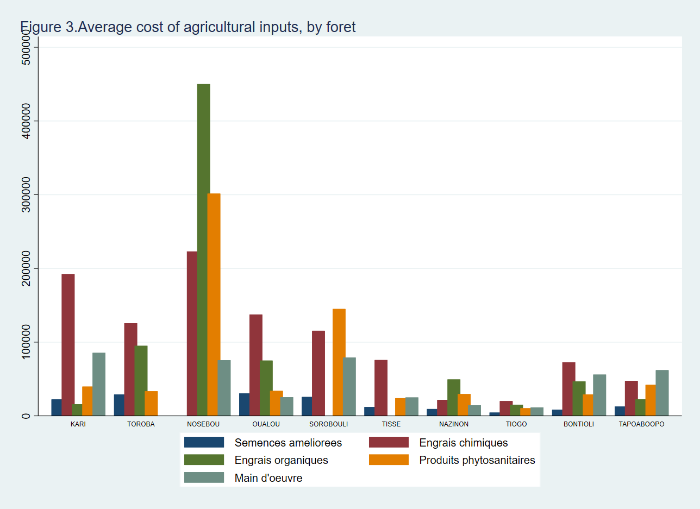

Figure 3 evaluates the cost of agricultural inputs by foret. Nosebou stands out among all forets due to the massive cost of organic fertilizers followed by pesticide products and chemical fertilizers. The cost of hired labour incurred by households is consistently small throughout the forets and so is the cost of improved seed varieties. Both Bontioli and Tapoaboopo, the two forets with the highest proportion of survey participants, indicate low incurred costs across all agricultural inputs.

Both control and treatment groups appear quite balanced with regards to agricultural production. According to table 7 below, we do not observe significant differences for any of the listed variables and the balance continues to be maintained even if we remove some of the extreme values in the total value of the agricultural production.

|  |  |  |  |  |  |
| --- | --- | --- | --- | --- | --- |
| Table 7. Balance tables  Agricultural production |  |  |  |  |  |
|  |  | (1) |  | (2) | t-test |
| Variable |  | Control |  | Treatment | Difference |
|  | N | Mean/SE | N | Mean/SE | (1)-(2) |
| Superficie totale de terres du menage | 259 | 12.129 | 262 | 16.149 | -4.02 |
|  |  | [3.840] |  | [4.822] |  |
| Superficie totale cultivee | 259 | 4.665 | 262 | 5.239 | -0.573 |
|  |  | [0.225] |  | [0.482] |  |
| Valeur totale des semences amelioree achetee | 74 | 16384.459 | 75 | 11965.733 | 4418.726 |
|  |  | [2536.624] |  | [2204.119] |  |
| Valeur totale des engrais chimiques achetes | 136 | 81455.515 | 139 | 94789.209 | -1.33E+04 |
|  |  | [8272.922] |  | [12627.713] |  |
| Valeur totale des engrais organiques achetes | 42 | 24833.429 | 37 | 41283.892 | -1.65E+04 |
|  |  | [9630.690] |  | [16509.044] |  |
| Valeur totale des produits phytosanitaires achetes | 148 | 35324.324 | 141 | 47562.057 | -1.22E+04 |
|  |  | [3375.911] |  | [7420.174] |  |
| Valeur totale de la main d'oeuvre achetee ou louee | 92 | 36152.174 | 96 | 40198.073 | -4045.899 |
|  |  | [5254.084] |  | [7081.721] |  |
| Valeur totale de la production agricole (1000s FCFA) | 259 | 1563.146 | 262 | 557.94 | 1005.207 |
|  |  | [881.425] |  | [48.012] |  |
| The value displayed for t-tests are the differences in the means across the groups. |  |  |  |  |  |
| ***, **, and * indicate significance at the 1, 5, and 10 percent critical level. |  |  |  |  |  |

# Food expenditure

The section on food expenditure investigates variables such as the expenditure on food purchased, expenditure on food derived from own production, food gifted from various sources and the total food expenditure – all these variables use a recall period of 7 days which comes with its own advantages and drawbacks.

From table 8, we observe that the average expenditure on food purchased over the past 7 days is roughly 11500 FCFA, only slightly higher than the average expenditure on food derived from own production[1].

|  |  |  |  |  |  |  |
| --- | --- | --- | --- | --- | --- | --- |
| Table 8. Overall summary statistics of food expenditure among survey participants | | | | | |  |
| Variable | N | Mean | S.D. | Median | Min | Max |
| Food purchased | 630 | 11482.8 | 12190.1 | 8025.5 | 0.0 | 152600.0 |
| Food from own production | 630 | 10714.6 | 27969.5 | 4625.0 | 0.0 | 362750.0 |
| Food gifted | 630 | 246.4 | 1100.0 | 0.0 | 0.0 | 15500.0 |
| Total average food expenditure | 630 | 22443.7 | 32031.0 | 15450.0 | 0.0 | 367650.0 |

Table 9 below provides further evidence with regards to the balance of the two groups. The only significant difference, albeit at the 10 percent level, appears to exist in the level of expenditure on the food derived from own production. The balance remains in place across the other variables.

|  |  |  |  |  |  |
| --- | --- | --- | --- | --- | --- |
| Table 9. Balance tables  Food expenditure |  |  |  |  |  |
|  |  | (1) |  | (2) | t-test |
| Variable |  | Control |  | Treatment | Difference |
|  | N | Mean/SE | N | Mean/SE | (1)-(2) |
| Expenditure on food purchased | 307 | 11699.879 | 323 | 11276.384 | 423.496 |
|  |  | [732.186] |  | [643.579] |  |
| Expenditure on food derived from own production | 307 | 12760.717 | 323 | 8769.814 | 3990.902* |
|  |  | [2191.092] |  | [608.821] |  |
| Expenditure on food gifted from various sources | 307 | 270.218 | 323 | 223.771 | 46.447 |
|  |  | [60.381] |  | [63.416] |  |
| Total food expenditure over the past 7 days | 307 | 24730.814 | 323 | 20269.969 | 4460.845* |
|  |  | [2396.651] |  | [993.290] |  |
| The value displayed for t-tests are the differences in the means across the groups. |  |  |  |  |  |
| ***, **, and * indicate significance at the 1, 5, and 10 percent critical level. |  |  |  |  |  |

According to figure 4 below that analyses the food expenditure by foret and treatment, the cost incurred from purchasing food generally appears to be higher for the control group, especially in Oualou and it is at comparable levels in Tiogo and Bontioli. The value of food derived from own production is extremely high in Tapoaboopo for the control group and contrastingly lower for the treatment group in the same foret.

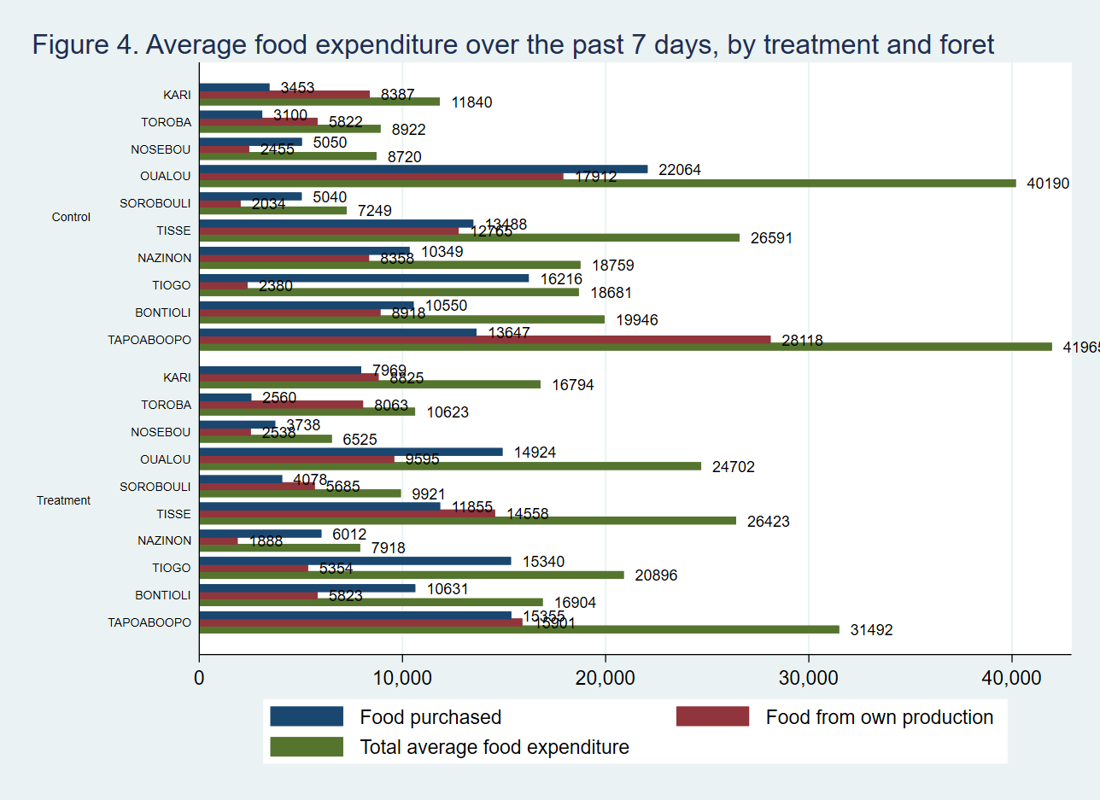

The findings of this baseline report point to a strong balance between the control and treatment groups across a plethora of indicators ranging from socio-demographic characteristics to assets, agricultural production and food expenditure.

1. It is not clear at this stage how the cost of food derived from own production is determined.